Option#1: R Portfolio Project

Sonya E. Ghebrechristos

MIS500: Foundations of Data Analytics

CSU-Global

Mills, Jamia

01/12/2019

The analysis to improve U.S. Healthcare

For the data analytics project, I have chosen to analyze the cost, safety, and the access to the society of U.S healthcare. Historically, the U.S. healthcare has not been at its best to the society in comparison of other western countries. In countries such us as Australia, universal healthcare is available to the population, which gives access to a quality care to all population despite their income statues. Whereas in U.S, the universal healthcare is out of the question, and the access to quality care varies by income statues of the person.

The proposal of the data analytics project on U.S. health care is to improve healthcare and make it more affordable with good quality to care. Health care in the United states is provide by many distinct organizations. The health care coverage is provided through a combination of private health insurance and public health coverage. The public health coverage such as Medicare, Medicaid is for those who are in poverty. By just having this kind of coverage, they have minimum access to quality treatments.

U.S. spends about $3 trillion per year on healthcare, or $10,000 per person per year. The figure shown below just an example of the cost and growth of US healthcare from the year of 2011 to 2019, the study shows little after the year of 2014 but is was determine that the health care cost growth dataset was conducted for three years from (2011- 2013), based on the result given the health care cost growth to 2% less than the projected national health expenditures average every year.

*Figure: Health care cost growth datasets*

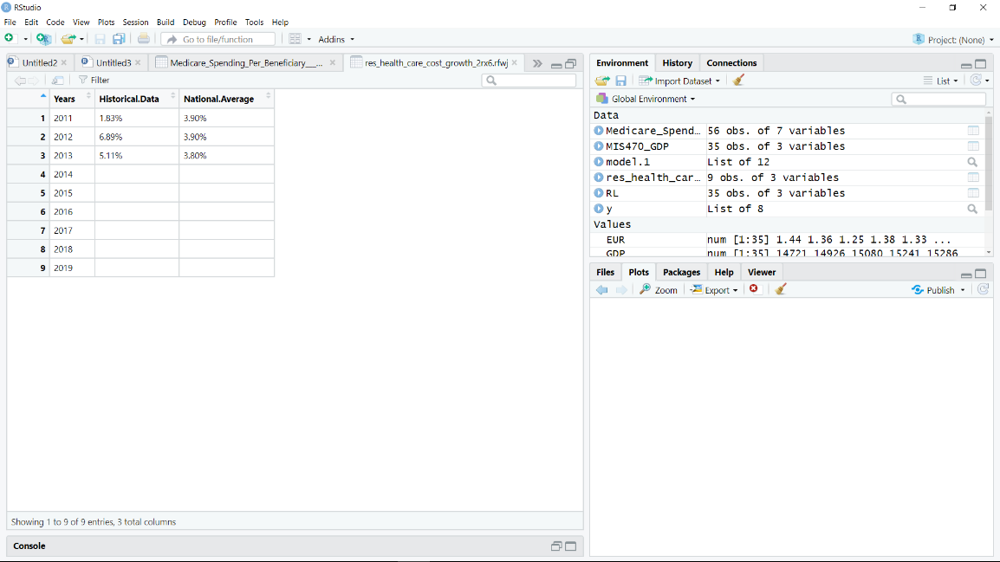

*Figure: summary (health Care cost growth datasets )*

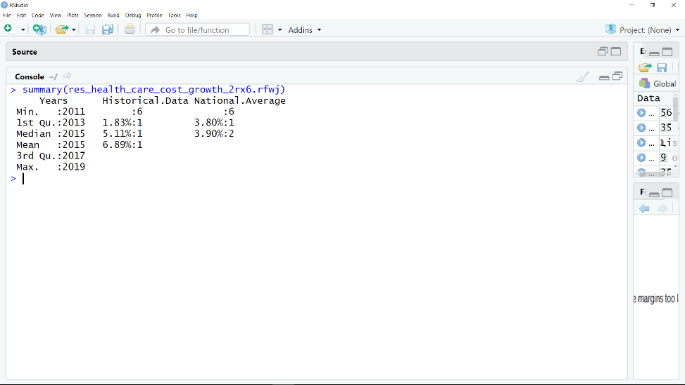

Even though U.S spend that much money on health care the cost of health care is still high. The graph below shows how much health care cost in U.S. in compression to Canada. the graph below was conducted from 2006 health spending per capital data. the result shows U.S healthcare cost 15% higher than Canada.

*Figure: graph (2006 health spend in Capital)*

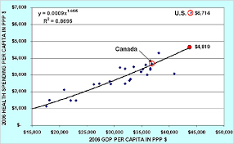

Healthcare provides Medicaid and Medicare to populations who are under the poverty rate income and to those who are 60 and above. The focus on this project is the Medicare, safety and healthcare and healthcare cost. For the data analytics project on U.S healthcare, some data were collected from large datasets on 125 years of US healthcare data ( <http://www/healthdata.gov/>). Medicare Spending Per Beneficiary (MSPB), Res health care cost growth, and Safety and healthcare datasets were obtained from <http://www/healthdata.gov/>), to provide a summarization, information content of U.S healthcare data in an easily understood format, from the datasets I was able to do the graphical representations of the , prepare of U.S heath care for detailed statically analytics.

Medicare spending per beneficiary (MSPB) dataset provides the information of Medicare spending per patient. The Medicare spending per beneficiary measures shows whether Medicare spends more, less, or about the same for an episode of care at specific hospital compared to all hospitals nationally. The data was conducted in all the states and the result was giving in score bases. The dataset includes Medicare part A and B payments for services provided by hospitals and other healthcare provides during the 30 days following a patient’s inpatient stay.

*Figure: Medicare spending per beneficiary dataset*

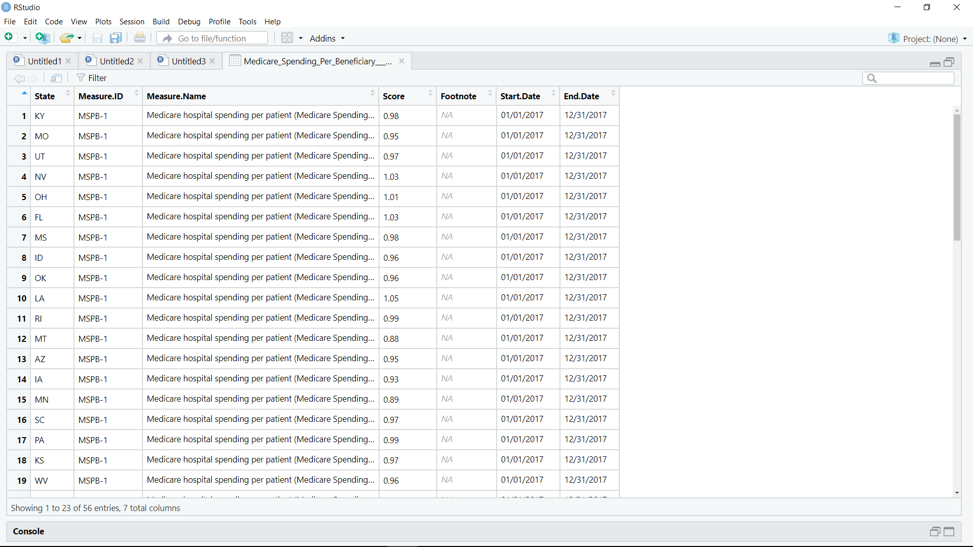

Example, In LA the score of Medicare spending per patient was 1.05, In Kansas 0.97, New York 0.98/person, Colorado was 0.96 from 01/01/2010 – 12/31/2017.

*Figure: Summary (Medicare spending per Beneficiary (MSPB)*

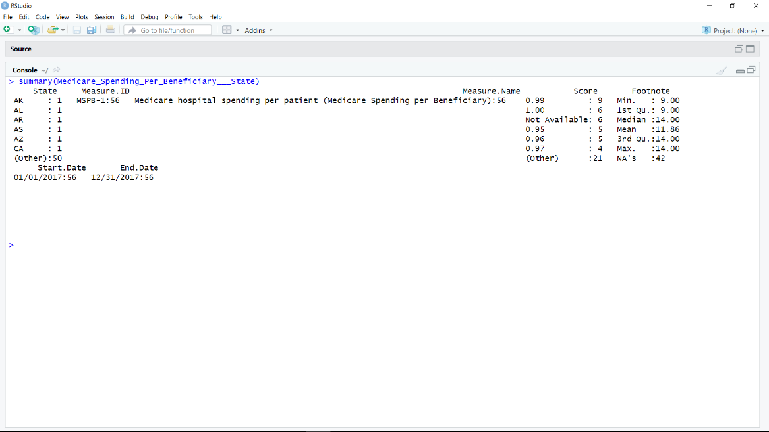

The statistical summary of MSPB above shows that minimum score of state which is AL and the mean of all the states score with is 0.95 and max which is 0.97. based on this result it is difficult to determine which part spends more, less or the same.

Even though that much money is spent on healthcare, the U.S healthcare is rank one of the worst healthcare. in America the infant mortality and other disease like chronic statistic is still high compare to other developed countries.

The data below is showing the measures of whether Medicare spends more, less, or same for an episode of care in a few states that was taken from the Medicare Spending Per Beneficiary (MSPB) data set.

State Measure.ID

1 KY MSPB-1

2 MO MSPB-1

3 UT MSPB-1

4 NV MSPB-1

5 OH MSPB-1

6 FL MSPB-1

Measure.Name

1 Medicare hospital spending per patient (Medicare Spending per Beneficiary)

2 Medicare hospital spending per patient (Medicare Spending per Beneficiary)

3 Medicare hospital spending per patient (Medicare Spending per Beneficiary)

4 Medicare hospital spending per patient (Medicare Spending per Beneficiary)

5 Medicare hospital spending per patient (Medicare Spending per Beneficiary)

6 Medicare hospital spending per patient (Medicare Spending per Beneficiary)

Score Footnote Start.Date End.Date

1 0.98 NA 01/01/2017 12/31/2017

2 0.95 NA 01/01/2017 12/31/2017

3 0.97 NA 01/01/2017 12/31/2017

4 1.03 NA 01/01/2017 12/31/2017

5 1.01 NA 01/01/2017 12/31/2017

6 1.03 NA 01/01/2017 12/31/2017

The proposal approach on the equality of U.S healthcare. the main idea is to fix the unfair work the healthcare industry in the U.S. this kind approach would establish the consistent of healthcare use among the population and the use to quality health care to improve the population health and decrease the infant mortality and chronic disease. The dataset below is the resulting pps exempt cancer hospital quality reporting program measures that allow consumers to compare the quality of care given cancer hospital of few states.

*Figure: ( Safety and healthcare associated measures pps.exempt cancer hospital datasets)*

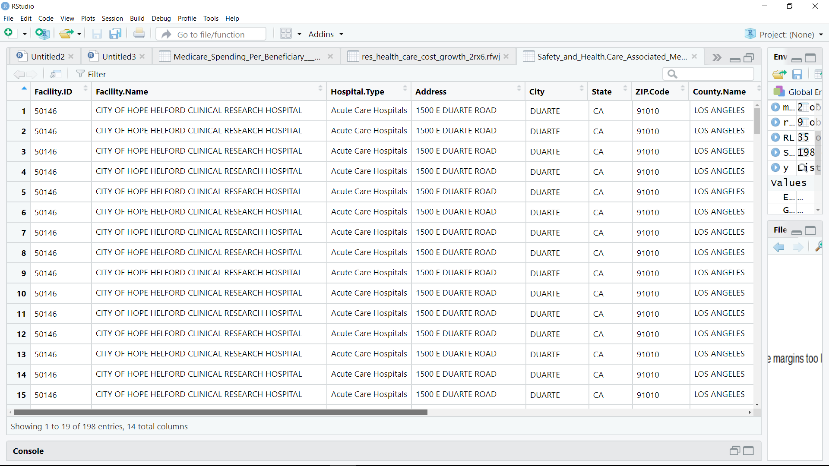

The figure below is the summary of the result of the quality of care given to cancer patient in cancer hospital, the result shows that the median, mean, are the same, same as the minimum. Based on the information given to is difficult to determine and conclude of what cause and find out how the cancer patient are being treated.

*Figure: summary (Safety and health care)*

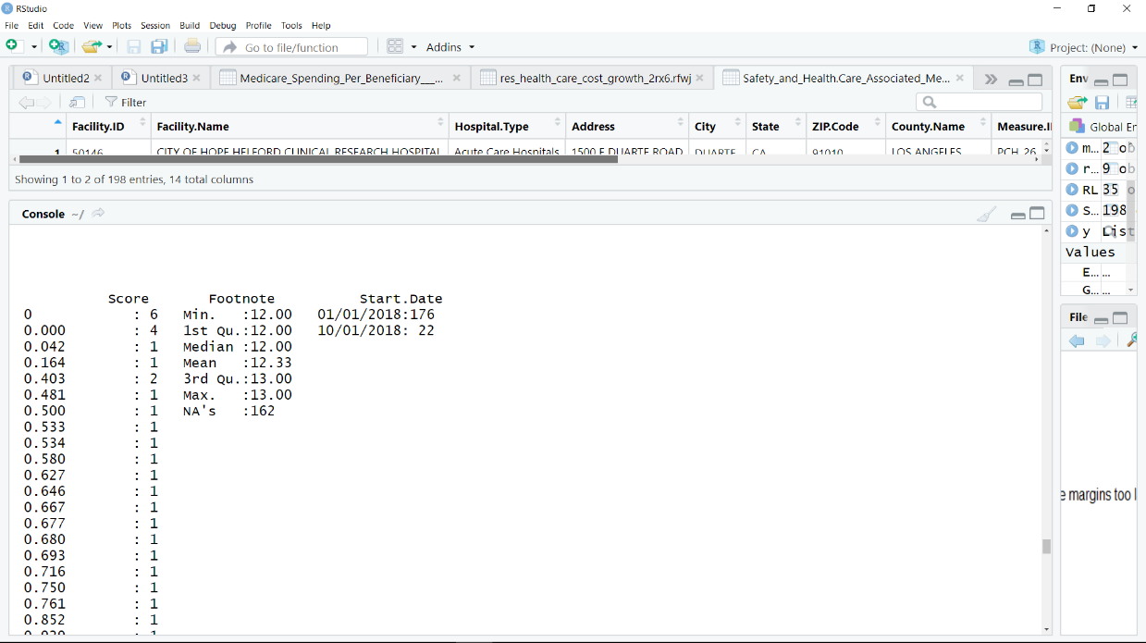

Conclusion:

The goal of the proposal is to reduce the uninsured, and those who are insured to get access to a quality healthcare, make coverage more affordable. the data analytics can make help a difference in US healthcare. an example can be by building a programmed that can not be manipulate and interpreted by others and put people at risk. as a data analytics the improvement of the performance of healthcare by delivering data-based quality care.

Reference:

*Black Book - U.S. Healthcare & United Healthcare*. Bernstein Global Wealth Management. Print.

“US Congress Clears Hist

orical Healthcare Bill.” Accord Fintech (2010): n. pag. Web.

Guah, Matthew W. Healthcare Delivery Reform and New Technologies : Organizational Initiatives . Hershey PA: Medical Information Science Reference, 2011. Print.

Rao CR, Raghavan V, Govindaraju V. *Big Data Analytics*. Amsterdam: North Holland; 2015. http://search.ebscohost.com/login.aspx?direct=true&db=nlebk&AN=1048869&site=eds-live. Accessed January 12, 2020.